Kristina Vasquez

Module 5.2

For all my examples here I am going to use music and where company’s like Spotify or Pandora may use them.

Function 1: CONCAT_ WS

This function is a way to put two strings together but unlike a normal CONCAT this one allows a character to separate the strings like spaces, comma or dashes. In this case I used it to show the artists on songs and concate artist_name and contributing_artist_name.

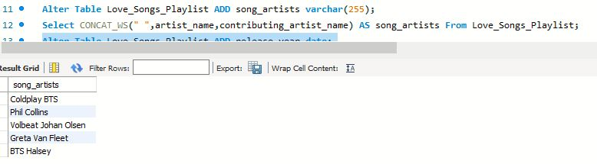

Function 2: Year

This function allows us to grab the year from date. This can be helpful for a company like spotify if they need to create playlists on a certain year. In this example I used this function on a single date to get the following output.

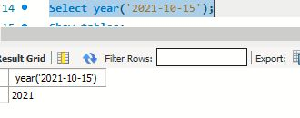

Function 3: STRCMP

This function is great to see if there are any strings that are the same. This would come into play with finding duplicate values in the database. In this case I wanted to make sure that the song title “Boy With Luv (feat. Halsey)” wasn’t the same as the contributing artists name “Halsey” since sometimes song titles, album names and artists names can all be the same. We get an output of -1 which according to W3Schools,” If *string1* < *string2*, this function returns -1” (*MySQL STRCMP() function*). This indicates these are not similar values at all.

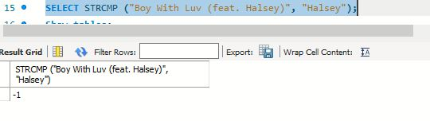

Citations:

MySQL STRCMP() function. (n.d.). https://www.w3schools.com/sql/func_mysql_strcmp.asp